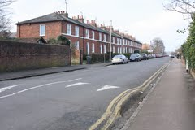 | Baker Street Area Neighbourhood Association  Expenses claim form

Expenses claimed by: | Example: Fred Bloggs
Project name: | Example: Fun Streets Pastry Class
Items: | Example: Various supplies for class: butter, flour etc as well as rolling pins and baking sheets.
Total: | Example: £130.00
Signature and date: | Example: Fred Bloggs 1st Jan 2016

Please include copies of all receipts by either stapling them to this sheet or photographs thereof pasted into the document
RECEIPT
Butter £20.00
Flour £30.00
Rolling pins £40.00
Baking sheets £40.00
TOTAL £130.00

